PHASE 3 — PROJECT DESIGN

INTRODUCTION :
Team ID : SWTID-2026-1655
Team Leader : SAKTHI.M
MAIL ID: msakthi6126@gmail.com
Team members :
NAME | MAIL ID
SAKTHI.M | msakthi6126@gmail.com
SOFIYA.M | sofiyamanikandan2007@Gmail.Com
SUMITHRA.E  SANGEETHA.M | sumithraelumalai172@Gmail.Com  sangeethamurugann01@gmail.co

3.1 Purpose of Project Design
This phase defines how the AnswerBot system is structured and how its components communicate. It converts the requirements into a technical design covering user flow, architecture, modules, database interaction, API flow, security and system roles.
3.2 System Architecture
AnswerBot follows a layered MVC-oriented backend structure. Client requests are received by the Express application, routed to the appropriate endpoint, checked by authentication middleware when required, processed by controllers/services, and connected to MongoDB through the models.
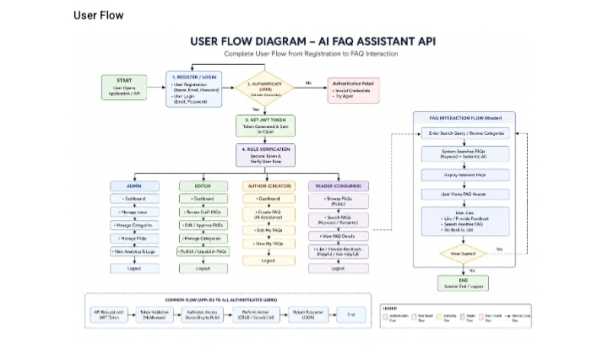
Figure 3.1 — User Flow Diagram – AI FAQ Assistant API
3.3 User Flow
The project flow shown in the supplied design is:
- User starts the application.
- User registers or logs in.
- Authentication is checked.
- A JWT token is generated after successful login.
- Protected requests send the token for verification.
- The authenticated user accesses functions according to the assigned role.
- FAQ interaction includes creating, viewing, searching and managing FAQ information where permitted.
- The system returns the requested response to the user.
3.4 MVC Architecture Pattern
Layer | Responsibility
Model | Represents application data and database schemas; handles database interaction.
View / Client | Represents the client/request side that sends requests and receives responses.
Controller | Receives requests, validates the workflow and coordinates the required operation.
Service | Handles reusable business/AI logic such as Gemini AI integration.
Database | MongoDB stores users and FAQ information.
3.5 Module Design
Module | Main Function
Authentication | Registration, login and JWT-based authentication.
User Management | User profile and role-related operations.
FAQ Management | Create, read, update and delete FAQ records where authorized.
FAQ Search | Search FAQ records using a query/category.
AI FAQ Generation | Generate FAQ question/answer content using Gemini AI.
Validation & Error Handling | Validate input and return consistent error responses.
3.6 API / Request Flow
The main request flow is:
Client → Express Route → Authentication/Validation Middleware → Controller → Service/Model → MongoDB or Gemini AI → Controller Response → Client
API | Method | Purpose
/api/auth/register | POST | Register a new user.
/api/auth/login | POST | Authenticate a user and return a token.
/api/faqs | POST | Create an FAQ for an authorized user.
/api/faqs/search?q=... | GET | Search FAQ records.
/api/ai/generate-faq | POST | Generate an FAQ using AI for an authorized request.
3.7 Database Design
Collection / Entity | Important Data | Relationship / Purpose
User | _id, name, email, password, role | Stores registered users.
FAQ | _id, question, answer, category, createdBy | Stores FAQ records and links them to the creator.
AI FAQ Generation | topic, generated question, generated answer | Represents content generated by the AI service.
3.8 Security Design
- JWT authentication is used for protected API operations.
- Passwords are protected using bcrypt.
- Authentication middleware verifies access tokens.
- Validation middleware checks incoming request data.
- Environment variables are used for sensitive configuration such as database and AI credentials.
3.9 Role-Based Access Design
Role | Designed Access
Admin | Manage users, categories and FAQ administration functions.
Editor / Content Creator | Create and manage FAQ content according to permissions.
Author / Contributor | Create or edit FAQ content according to assigned permissions.
Reader / Public User | View/search published FAQ information; cannot access protected management functions.
3.10 UI / Interaction Design
The project is primarily a REST API. Therefore, the design focuses on request/response interaction, authentication flow, role-based access and API results rather than a separate graphical frontend.
3.11 Design Output Checklist
- User Flow Diagram
- MVC Architecture Diagram
- Module Design
- API Request Flow
- Database Design
- Security Design
- Role-Based Access Design
- UI / Interaction Design
- API Endpoint Design
3.12 Conclusion
The Project Design phase defines the technical structure of AnswerBot and provides the blueprint for development. The supplied User Flow and MVC diagram is included as the main design evidence, supported by the API, database, module and security designs above.

